# JS Advanced: Exam 18 March 2018

Problems for exam preparation for the [“JavaScript Advanced” course @ SoftUni](https://softuni.bg/courses/javascript-advanced). Submit your solutions in the SoftUni judge system at <https://judge.softuni.bg/Contests/974/>.

# Problem 4. Payment Manager (Object Interacting with DOM)

Write a JS **class** with the name **"PaymentManager"** that generates and controls a **payment manager** table. It contains **three columns** for payments data **(Name, Category, Price)** and **one column** for **Actions - [Add]** and **[Delete]** buttons**.** The **last row** of the table consists of **three** **input fields** and a **[Add]** button. There can be **multiple** **payment manager tables** – i.e. instances of the JS class. *See the examples and templates for more details.*

The **constructor** of your class needs to take **one** argument – **title** (string). The **title** should be used in the table’s title (<caption>). *See the table’s HTML template for more details below*.

Additionally, the **class** **should** **contain** the following **functionality**:

* Function render(id)– takes **one** (string) argument, **generates the table’s HTML element** and **appends** it to the **element in the DOM** **with ID equal** to the argument

The **table** **consists of** a **title**, **four columns** (name, category, price and actions), **three input fields** and **two** **types** of **buttons** (add, delete). You **should** **use** the following **HTML structure** **for** generating the **table**:

|  |
| --- |
| Template Table |
| <table>  <caption>{Title} Payment Manager</caption>  <thead>  <tr>  <th *class*="name">Name</th>  <th *class*="category">Category</th>  <th *class*="price">Price</th>  <th>Actions</th>  </tr>  </thead>  <tbody *class*="payments">  <tr>  <td>*<!-- Payment's name -->*</td>  <td>*<!-- Payment's category -->*</td>  <td>*<!-- Payment's price -->*</td>  <td><button>Delete</button></td>  </tr>  <tr>...</tr>  </tbody>  <tfoot *class*="input-data">  <tr>  <td><input *name*="name" *type*="text"></td>  <td><input *name*="category" *type*="text"></td>  <td><input *name*="price" *type*="number"></td>  <td><button>Add</button></td></tr>  </tfoot>  </table> |

**Types** of **values** in a **payment’s** **columns**:

* **Name – string**
* **Category – string**
* **Price – number**

Every **input box** corresponds to the **payment’s column** it is **placed on**,where the data should be added.

Furthermore, when **clicked** the table’s **buttons** should have the following **functionality**:

**[Add] button:**

* **Appends** the **text** received from the **input boxes** and a **[Delete]** button as a **new** **row at the end** of the **table’s payments**
* **Clears** the **input boxes** after the **payment’s information** is **submitted**
* **Do nothing** if **either** of the **text boxes** is **empty**

**[Delete] button:**

* Should **remove** the table’s **row**,where it is placed on

Note that, **every button’s functionality** should work **only** for the **table** **where it is located on**.

### Submission

Submit only your **PaymentManager** class.

### Examples

You can use the following HTML skeleton to test your functionality:

|  |
| --- |
| index.html |
| <!DOCTYPE html>  <html *lang*="en">  <head>  <meta *charset*="UTF-8">  <title>Payment Manager</title>  <style>  body{padding:30px}div{margin-bottom:20px}table{border:1px solid #000;border-collapse:collapse;margin:auto}caption{font-size:20px;font-weight:700;color:#fff;background:#000;padding:5px}td,th{padding:5px 20px;text-align:center}tfoot td,th{background:#ccc}tr*:nth-child*(odd){background:#eee}tr*:nth-child*(even){background:#ddd}tfoot{border-top:1px solid #000}tfoot>tr td{font-style:italic;font-weight:700}button{margin:auto;cursor:pointer}  </style>  <script *src*="https://code.jquery.com/jquery-3.3.1.min.js"></script>  </head>  <body>  <div *id*="amazon"></div>  <div *id*="ebay"></div>  <div *id*="walmart"></div>  <script *src*="./solution.js"></script>  <script>  $(function() {  let paymentMangersData = [  ['amazon', 'Amazon'],  ['ebay', 'eBay'],  ['walmart', 'Walmart'],  *// Others*  ]  *for* (let [target, title] of paymentMangersData) {  let paymentManager = new PaymentManager(title)  paymentManager.render(target)  }  })  </script>  </body>  </html> |

The sample page contains three main table’s element and a script. The script will create two different payment manager tables that should look like the examples, if your code is correct. There is a third commented out manager’s data that you can use in the script. You need to put the files – index.html and solutions.js (where is your PaymentManager class) – in the same directory for them to work with the default code.

In the **first example** we will use only the first payment manager’s data in the script and generate only one table.

**Initial table rendering**:

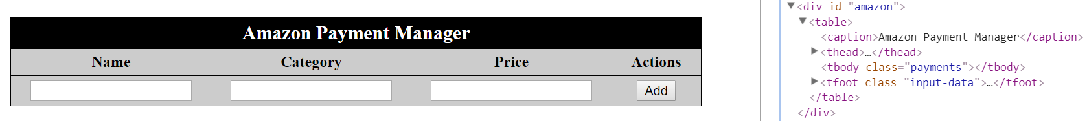

Use the "Template Table" skeleton to build your table.

**Adding** the **first payment**:

We add the first payment and two more after that, becoming the total of three payments.

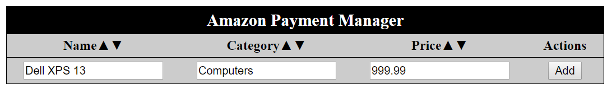

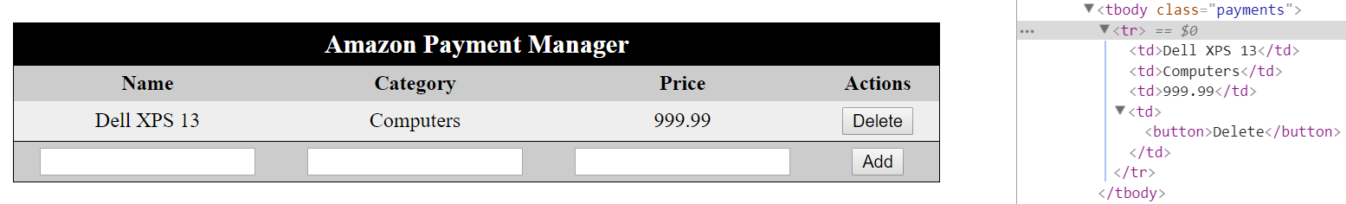

Then we add two more payments – "JavaScript The Good Parts" and "Audeze LCD-3" and click to delete a payment:

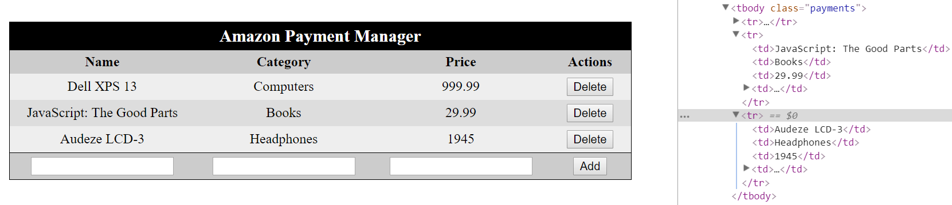

After deleting the payment with column name’s value – "Audeze LCD-3":

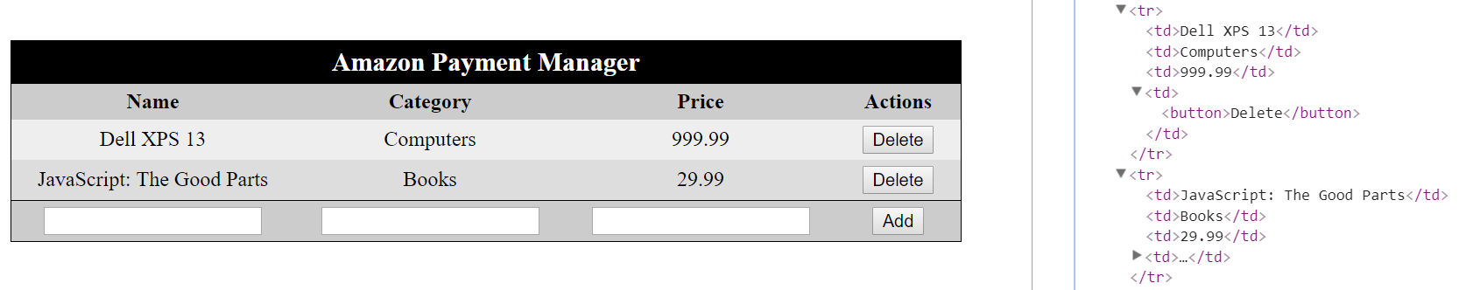

In the **second example** we will use two payment manager’s data in the script to generate two tables.

**Initial tables rendering**:

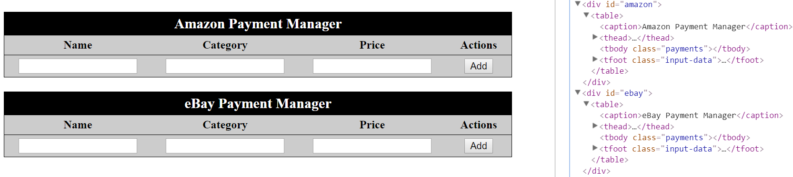

Chain of **commands** to the tables:

* **Adding** payments to Amazon Payment Manager
* [ "Logitech MX Master", "Mouses", "149.99" ]
* [ "Dell XPS 13", "Computers", "999.99" ]
* [ "Oree Board", "Keyboards", "80" ]
* **Adding** payments to eBay Payment Manager
* [ "V60 Cherry Dolch", "Keyboards", "105" ]
* 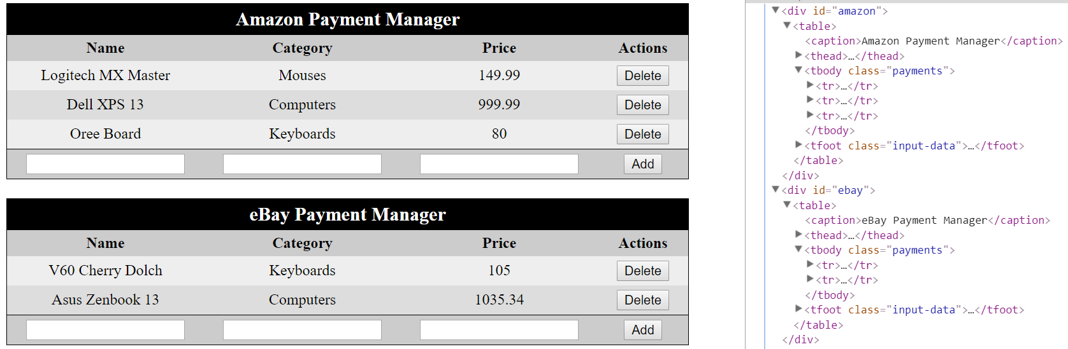[ "Asus Zenbook 13", "Computers", "1035.34" ]

More commands:

* **Delete** the **payment** with column name "Logitech MX Master" from **Amazon Payment Manager**

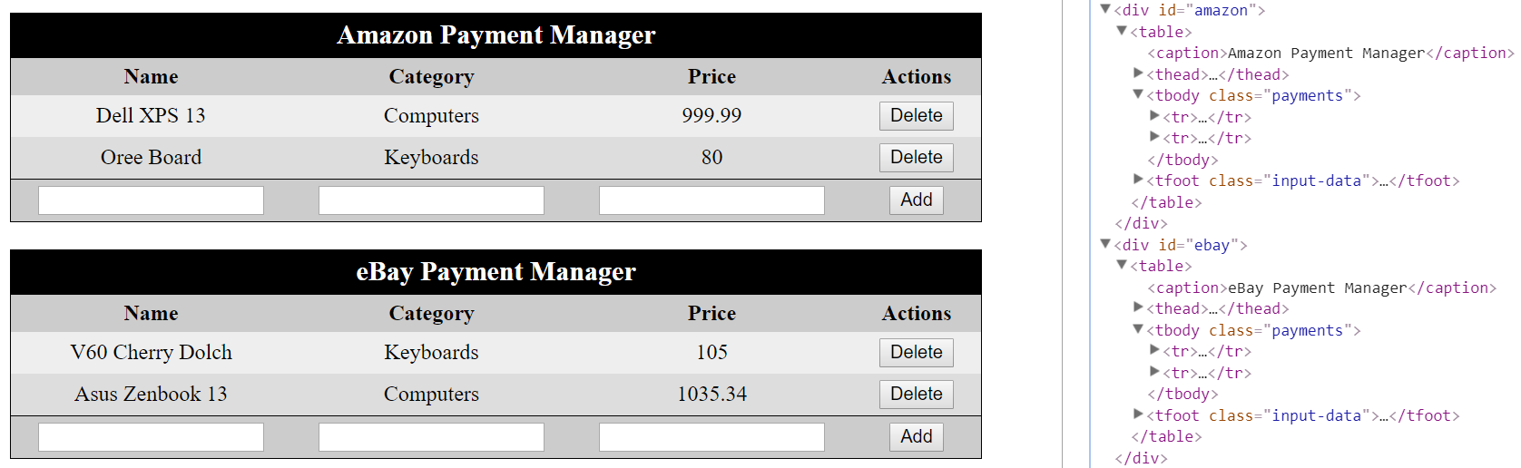

More commands:

* **Adding** a **payment** to **eBay Payment Manager**:
* [ "Oree Board", "Keyboards", "80" ]
* **Delete** the **payment** with column name "Oree Board" from **Amazon Payment Manager**
* **Adding** a **payment** to **Amazon Payment Manager**:
* [ "V60 Cherry Dolch", "Keyboards", "105" ]
* **Delete** the **payment** with column name "Asus Zenbook 13" from **eBay Payment Manager**
* **Delete** the **payment** with column name "V60 Cherry Dolch" from **eBay Payment Manager**

